|  |  |
| --- | --- |
|  | Instructor:  Dr. Talha Shahid |
| Computer Systems & Programming |
|  |  |

[](https://www.myperfectresume.com/membership/RegisterGuestUser.aspx?wizard=true&productid=17&utm_source=hloom-com&utm_medium=referral&utm_campaign=word-template)

Home Tasks of Lab Manual 7

**SYED FAKHAR ABBAS**

ME-15-C

466960

X

Xx

**Introduction:**

The Pakistan EPA National Environmental Health Policy (NEHP) is a plan to protect and improve Pakistani people's health by reducing the risks from environmental hazards. It addresses

**Lab Task# 1:**

Take 10 integer inputs from user and store them in an array and print them on screen.

Code:

#include<iostream>

using namespace std;

int main (){

int c=5,r=5;

char arr[r];

//upper triangle

for (int i=0;i<=r/2;i++){

arr[i]=' ';

}

for(int j=0;j<=c/2;j++){

arr[c/2-j]='*',arr[c/2+j]='*';

cout << arr << endl;

}

//lower triangle

for (int i=r/2+1;i<r;i++){

arr[i]='*';

}

for(int j=c/2+1;j<c;j++){

arr[j-4]=' ',arr[j-3]=' ';

arr[7-j]=' ',arr[9-j] = ' ';

cout << arr << endl;

}

}

Result:

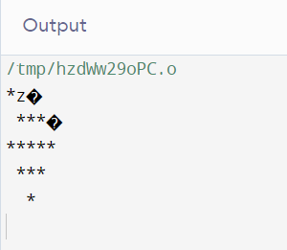

**Lab Task# 2:**

Write a program to find the sum and product of all elements of an array with 5 integer elements.

Code:

#include <iostream>

using namespace std;

int main(){

int product, sum;

cout<<"Enter the 5 elements of the array";

int ele[5];

for(int i=0; i<5; i++){

cin>>ele[i];

}

sum=ele[0]+ele[1]+ele[2]+ele[3]+ele[4];

cout<<"The sum of the elements in the array is"<<sum<<endl;

product=ele[0]*ele[1]*ele[2]*ele[3]*ele[4];

cout<<"The product of the elements in the array is"<<product;

}

Result:

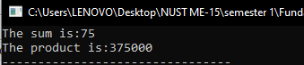

**Lab Task# 3:**

Print diamond pattern using a single array.

Code:

#include<iostream>

using namespace std;

int main(){

int n=3;

for(int i=0; i<3; i++){

for(int j=0; j<n-i-1; j++){

cout<<" ";

}

for(int j=0; j<2*i+1; j++ ){

cout<<"*";

}

cout<<endl;

}

for(int i=n-2;i>=0; i--){

for(int j=0;j<n-i-1; j++){

cout<<" ";

}

for(int j=0; j<2*i+1; j++){

cout<<"*";

}

cout<<endl;

}

return 0;

}

Result:

